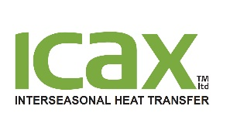

**How to Get Paid by ICAX Ltd**

# The standard terms of payment for supply chain contracts are 30 days for sub-contractors and the supply chain.

# Address to which invoices & statements should be sent:

accounts@icax.co.uk

**Email address to which invoices should be sent:**

[accounts@icax.co.uk](mailto:accounts@icax.co.uk%20) – preferred method is one PDF file per invoice

**Purchase order requirements**

All invoices should quote a purchase order. Invoices that do not quote a valid purchase order may be returned to the supplier to resubmit the invoice with a correct purchase order.

**Payment run dates in month**

Payment runs take place two working days before the last working day of the month and on a weekly basis every Thursday.

**Date by which an invoice must normally be received and approved to be included in the next payment run**

four days

**Contact details for invoice payment queries & statements**

[accounts@icax.co.uk](mailto:accounts@icax.co.uk)

or 0208 785 4887

**How are disputed invoices dealt with?**

All queries are responded to within 48 hours and disputed invoices are referred to the buyer who placed the order for the goods or services

**Normal expected timescale for invoice approval from receipt**

Upon receipt of goods or services

**Is an e-invoicing system utilised?**

Not at present

**Other important information for suppliers**

Invoices should quote bank account no, sort code and name of account.

IBAN numbers should be quoted on all invoices to be paid into non-UK bank accounts or non-sterling accounts